LINUX Introduction
What is OS?
OS is Operating System/platform, it will communicator between user and hardware(processor).
flyovers of UNIX:-
1. HP-UNIX ->commercial
2. IBM- AIX ->commercial
3. SUN -SOLARIES ->commercial
4. RED HAT Linux ->open source
RED HAT Linux flyovers -> Cent OS(cmd/GUI) , Ubantu(cmd/GUI) , Fedora(cmd) ,Debain(GUI)...etc
*Diff b/w open source and commercial products ?
-Basic cmnds are same , only advanced features like user creation and permissions , security will be different ....etc

LINUX CMNDS

In Real Time User creation (With sudo admin permission will provide) -> If any cmnd using should use sudo for every cmnd (first time will ask pwd, if 15 mints will not execute any cmnd will ask pwd again).
https://www.chiark.greenend.org.uk/~sgtatham/putty/latest.html -> putty download software
Install putty : putty-64bit-0.74-installer.msi

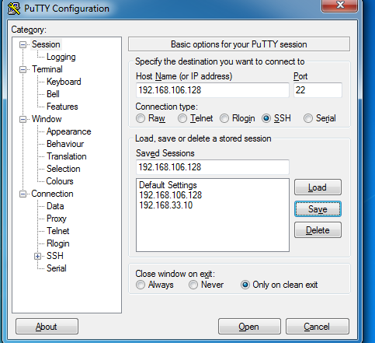
SSH (Secure Shell – By default port : 22)
Click save for future reference -> open
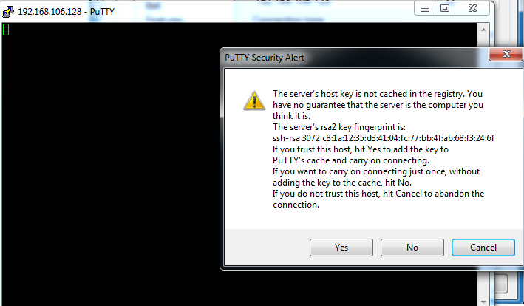

First time will open like this -> click yes.
Login as: root/lakshman
Pwd: devops@123
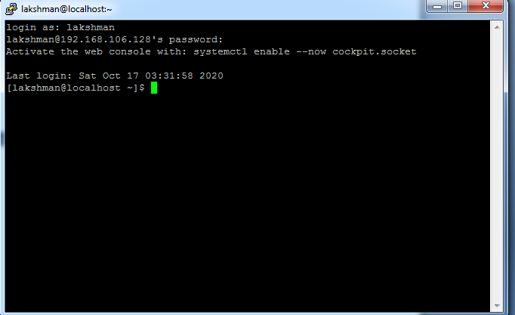

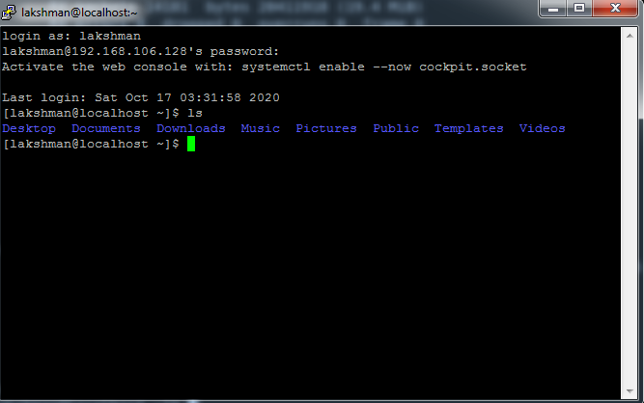
Increase font size ->right click on main bar ->change settings

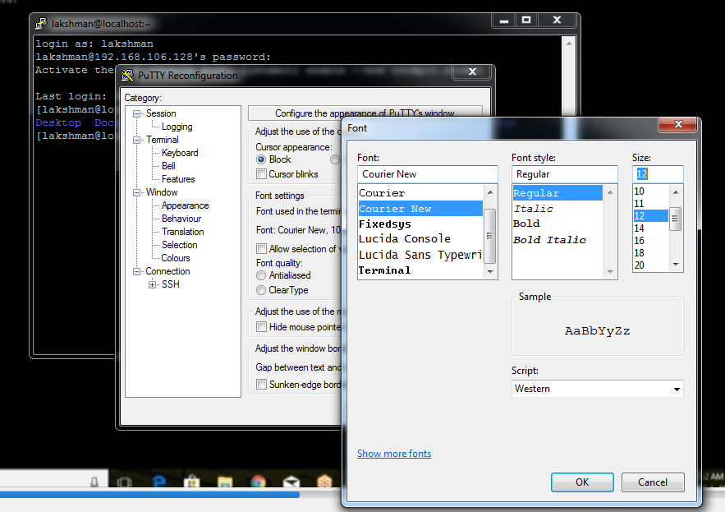

cd / -> home directory
ls -> to list the files and directories
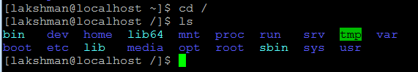
Bin -> normal user executed cmds stored here
Dev -> dev related
Home ->user home cmds
Lib ->library files
Media ->pen drives
Etc -> all configuration files here
Opt -> optional files (backup files)
Var,srv,sys,usr -> default directories
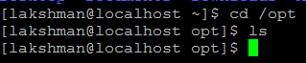
Here create all cmds 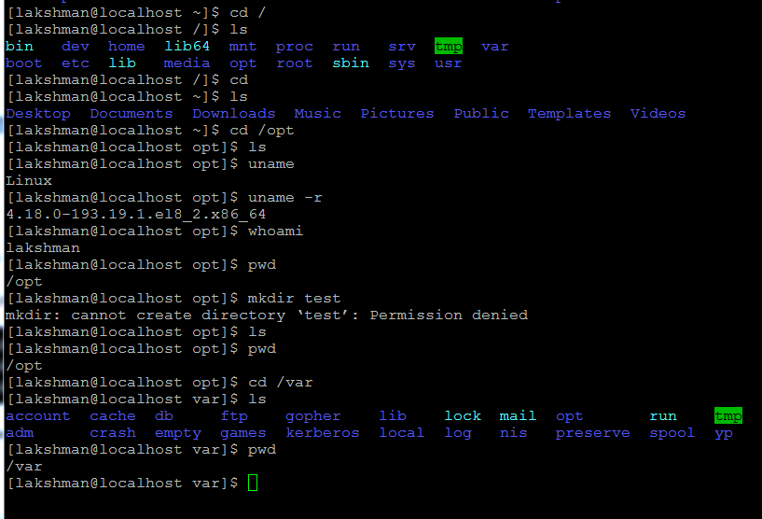
ls –l (list of long files)
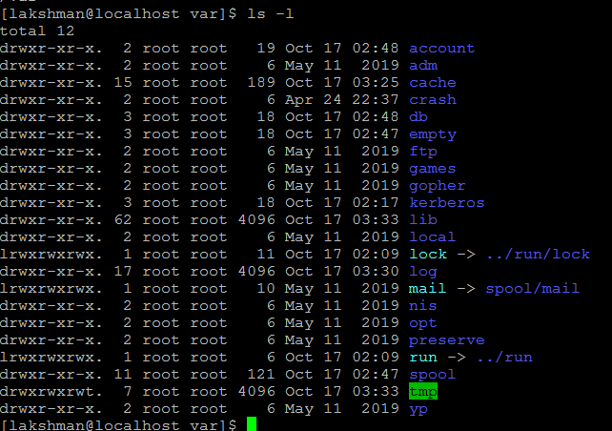
drwxr-xr-x. 2 root root 19 Oct 17 02:48 account(this is directory starts d)
file/directory permission
root – user
root -group
19 Oct 17 02:48 –date
Account (this is directory starts d of permission)
pwd -> present working directory
cd .. -> one step back
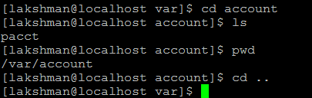
Goto directory and back.
ls –la or ls –a -> find hidden files (.test file or .test directory – if any file/directory use dot of starting it will be hidden files/ hidden directories)
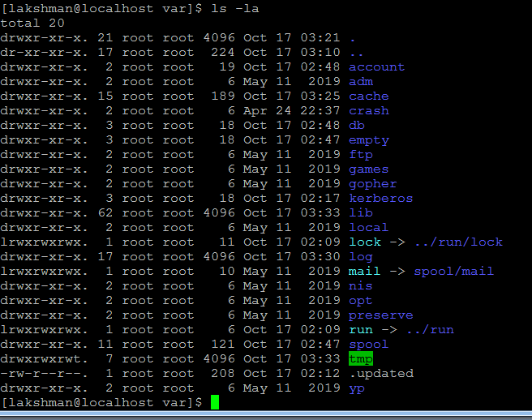

clear → clear the screen
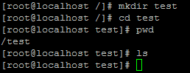
mkdir -> to create directory
touch -> create files
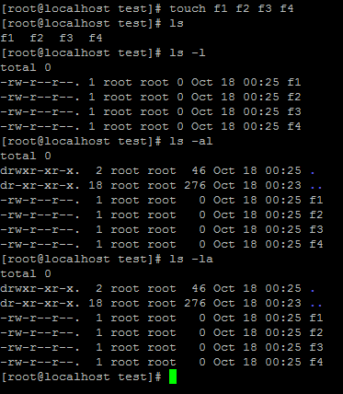
Create hidden file
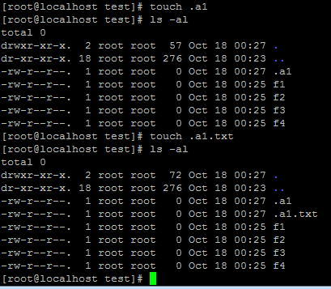
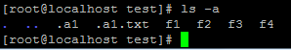

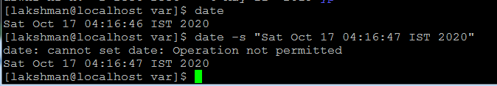
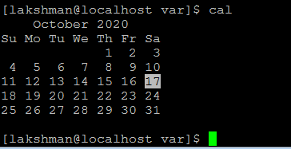
Login as root/devops@123
date -> display today date
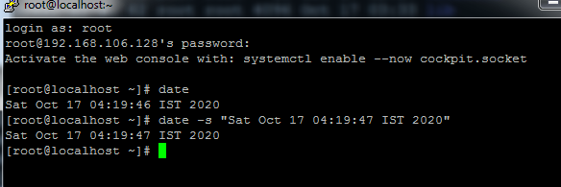
Date -s -> change date
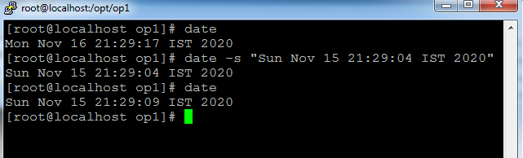

Cal 2020 -> display 2020 full calendar
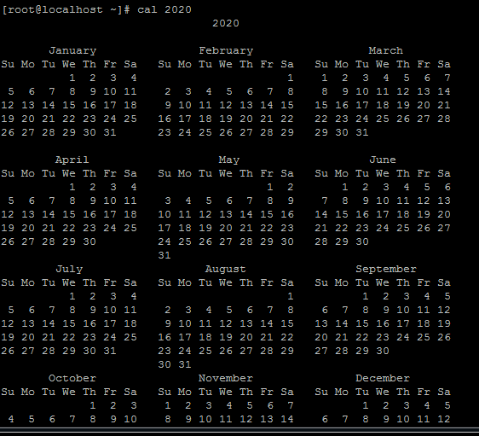
Cal 10 2020 -> display only 10th month of 2020 calendar
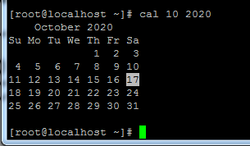

cd ~ (twit symbol) -> goto root directory
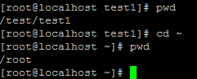
cd ../.. -> goto home directory
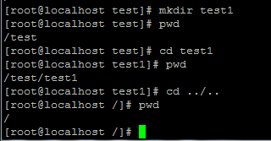

cd -> goto root directory
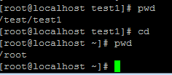
rm -> remove file
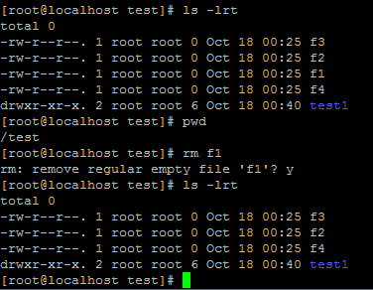

Remove multiple files
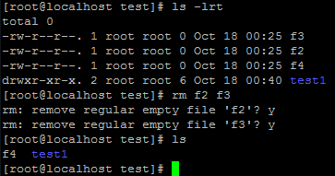
rm –f f4 -> remove forcefully file without conformation by user
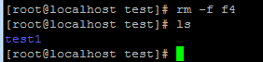
Create multiple individual directories
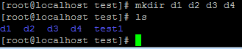
Create multiple nested directories
mkdir –p a1/a2/a3/a4
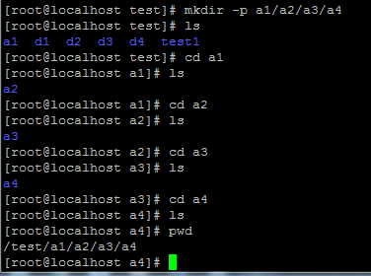

rmdir a3 -> remove directory (if any file are available, directory will not remove, first remove files after remove directory)
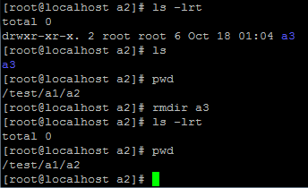
if any file are available, directory will not remove, first remove inside files after remove directory
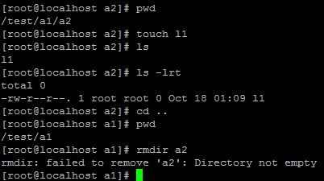

rm –rf * -> here rm –> remove, rf -> recurs force , * -> all
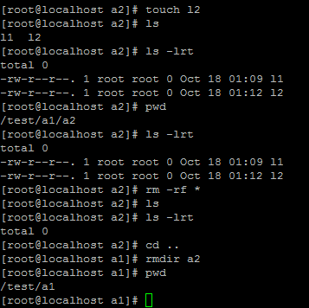

Some files created in d1 directory , trying remove directory with below cmnd
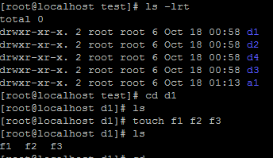
rm –rf d1 -> d1 directory will remove if file are exists also .
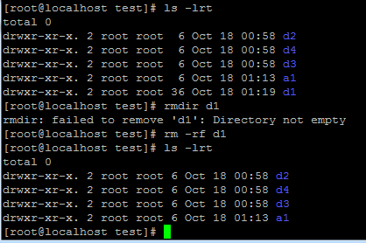
Vi editor modes: - insert mode (i) , execution mode(to execute scripts) , command mode(by default will open).
Vi sample -> file editor will open
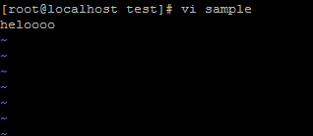
Press i for insert mode.
Type some thing msg
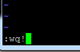
Esc :wq! -> save and quit the file
Esc :q! -> quit the file (without save )
Cat sample -> show file content
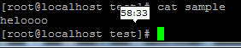
VI Editor cmnds:- use esc with below all below cmns (esc+dd)
dd -> remove current cursor line
3dd -> remove 3 lines from cursor (in 3 place give any number - ndd)
yy ->copy entire line
nyy -> copy n no.of lines (ex: 3yy)
p -> paste
u -> undo
shift+G ->goto last/buttom line (G-ground)
shift+H ->goto first/top line(H-head)
/ -> for searching
dw -> remove word
x -> remove particular char/letter
o-> new line will create on below cursor
r -> (small r)- replace single char
R (shit+r) ->(capital R) – replace whatever your writing content
w -> move word by word

Copy above content and paste vi editor (right click it will paste)
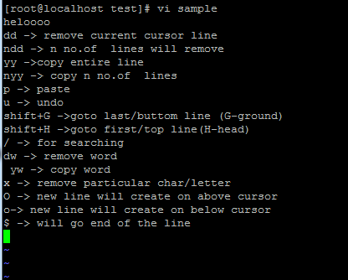

cp source dest -> cp sample d3 (sample file coped to d3 directory)
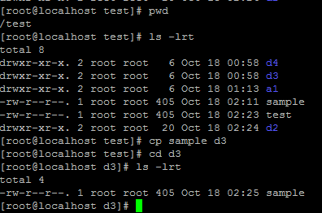

mv source dest -> mv sample d4 (mv means cut and paste into the dest location)
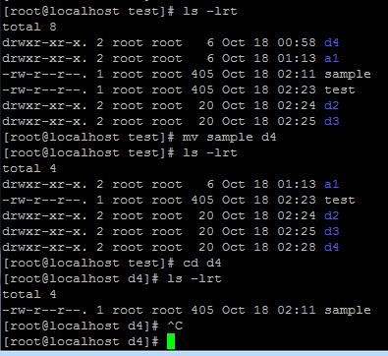

mv cmnd used rename the file.
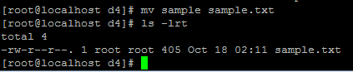
mv cmnd used rename the directory.
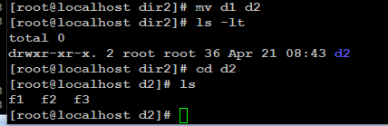
Move directory with inside files to other directory
cp –rf d3 d4 or cp –r d3 d4 -> if files available inside directory use rf or r.
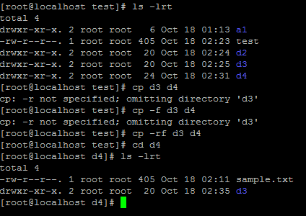

mv d2 d4 –> cut that directory(d2) with inside files to paste into other directory(d4)
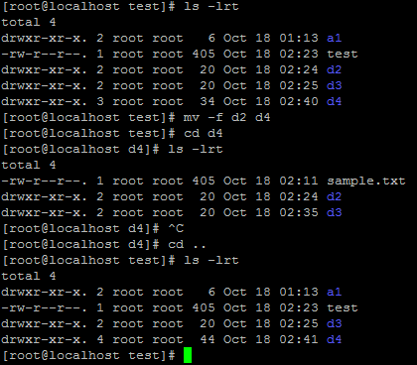

wc ->word count of the file
wc sample
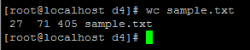
27 –lines
71 –words
405 –letters
Check in word count with multiple files
wc smple.txt sample1
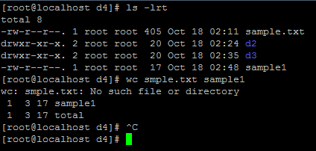
wc –l -> lines count
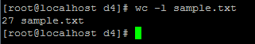
wc –c -> chars count
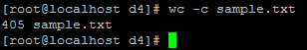
wc –w -> words count
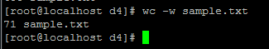

wc –lcw -> chars count
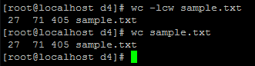
ls –lt -> display latest created or modified list as ascending order
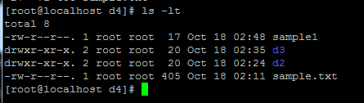

ls –ltr or ls –lrt -> display latest created or modified list as descending order
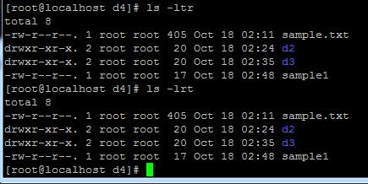
Permissions :- d rwx-rwx-rwx.
d rwx r-x r-x 2 root root 20 Oct 18 02:25 d3
d- directory rwx r-x r-x
types of user: 1.user ,2.group, 3.others
r (read) -4
w(write) -2
x(execute)-1
total =7
644 rw- r-- r-- (default permission for file) OR 744-rwx r r OR 774- rwx rwx r ->RT
chmod – change mode of file permission
chmod +x test
chmod -x test

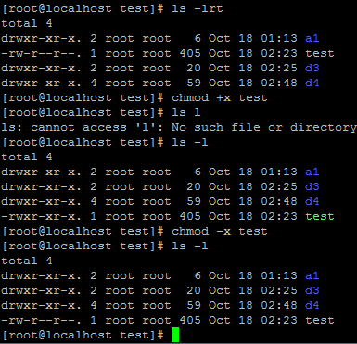
Note: Which user is created file, that user can use chmod.
Root user can do anything, normal user can do only on bases permission.
rw rx r - 6 5 4
chmod 654 test
rwx r r - 7 4 4 ->Real Time
chmod 777 test – full permission.
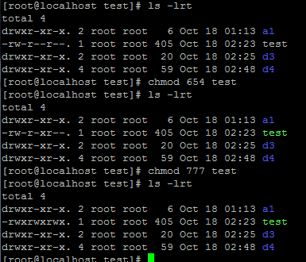
Creating script
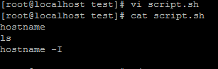
Sh file don’t have execute permission
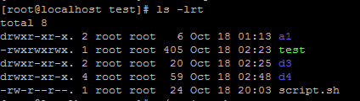
Not execute – permission is not given
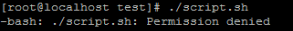
OR
[root@localhost opt]# sh script.sh
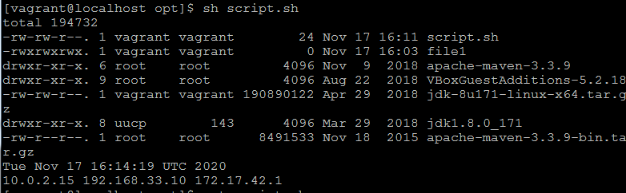
Provide execute or full permission.
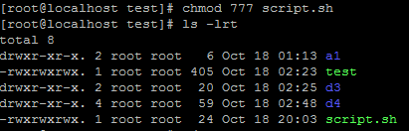

Run script
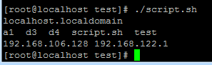
Created test1 directory with 6 files(all having by default permissions)
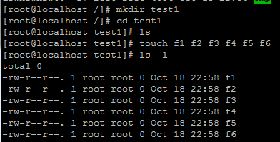
Giving full permission for test directory
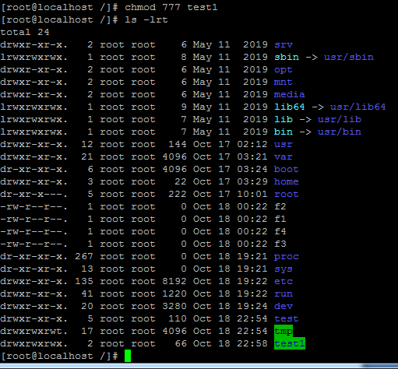
test1 got full permission.
Note: here only test1 dir got full permission but not inside files.
If you want rw permission for inside files also use –R

chmod 666 -R test1 ->it will get 666 permission for all inside files
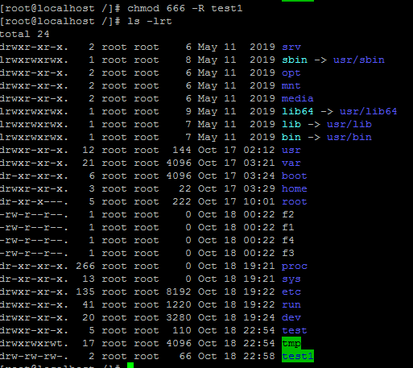
For specific file change full permission
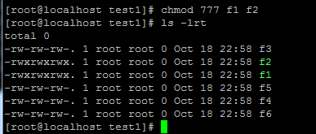

How to communicate 2 users:-
Take duplicate session and login as normal user
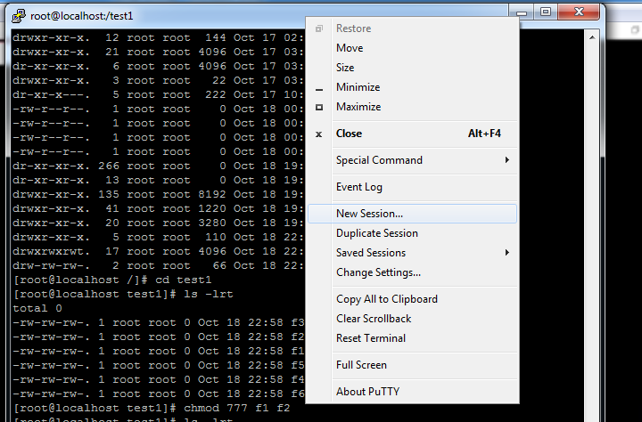

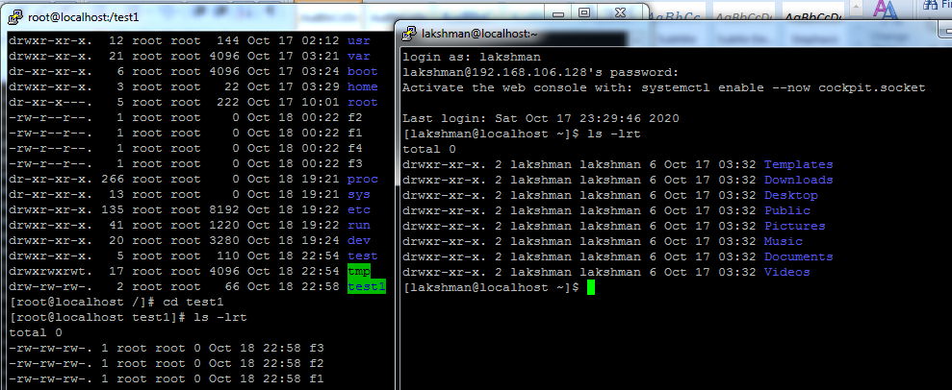

Message commutation for all users
[root@localhost test1]# wall -n "hello"
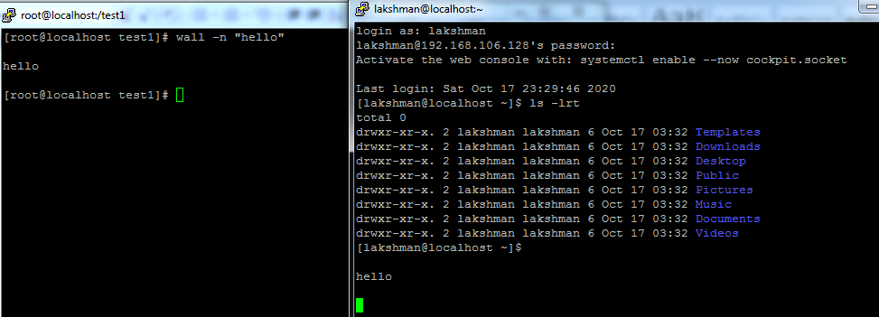
How to commutate particular user:-
[root@localhost test1]# write lakshman
hello devops (ctrl+c -> come out)
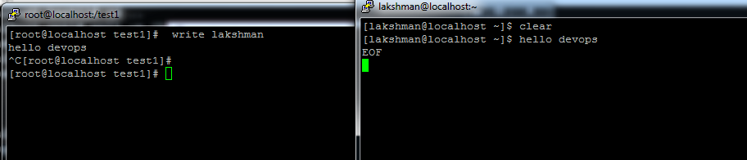

/etc dir having all configuration files available. –under home dir
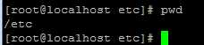
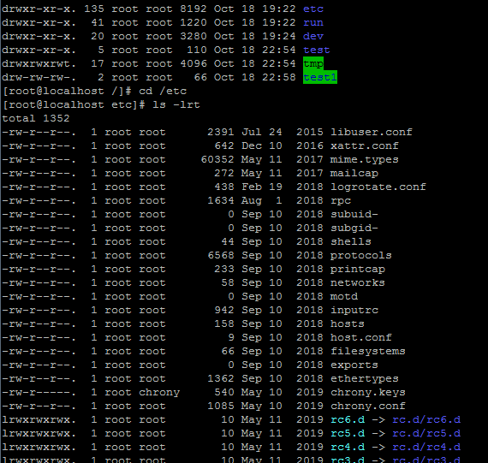

[root@localhost etc]# cat passwd -> stored all user applns related pwds in this file.
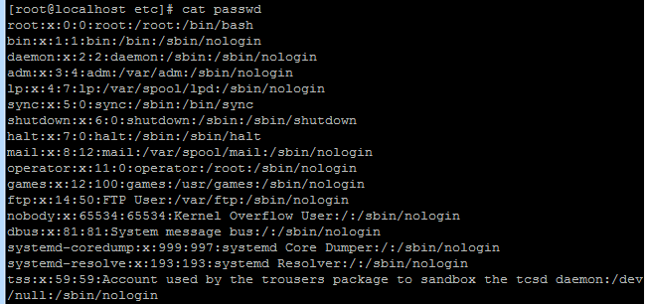
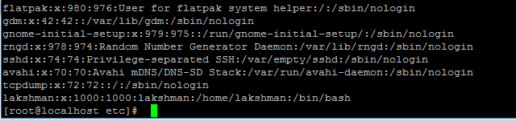
Create user:-
[root@localhost etc]# useradd devops -> devops user is created
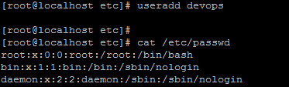
devops user is created
devops:x:1001:1001::/home/devops:/bin/bash
devops ->user name
x ->pwd key
1001->user id
1001->group id
:: -> comment (optional)
/home/devops->home dir (while user login show this dir)
/bin/bash->default shell dir (while shell script writing use this dir)
Change/set pwd for user:-
[root@localhost etc]# passwd devops ->devops is user name
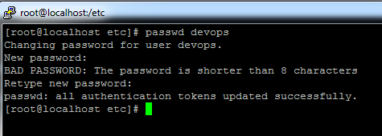
Pwd changed to devops1 , take duplicate session and login with new pwd.
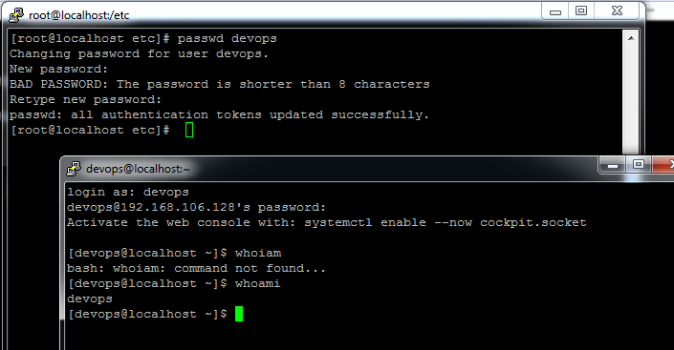

How to provide different home dir for new user:- this will take care by sys admin but should be aware paths.
[root@localhost etc]# useradd -d /var/devops1 -m devops1 ->-d is dir ,devops1 is new user.
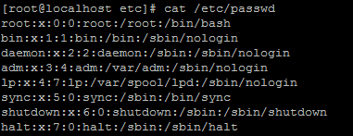
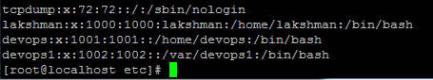
Home dir created -> /var/devops1
Change user home dir:- usermod
[root@localhost etc]# useradd -d /var/devops1 -m devops1
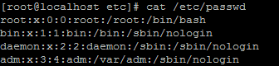
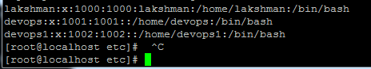
/home/devops1 -> home dir changed
[root@localhost etc]# usermod -s /var/bash devops1 -> -s used to change shell dir
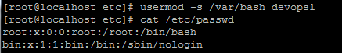
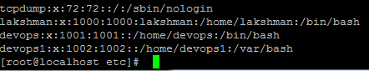
/var/bash -> changed shell dir

How to add comment msg to user:-
[root@localhost etc]# usermod -c "sample user" devops1 ->-c is give comment for user
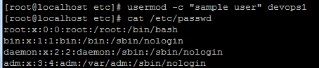
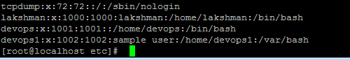
How to set pwd to new user:-
[root@localhost etc]# passwd devops1
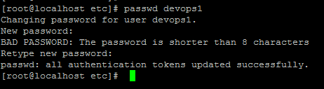
[root@localhost etc]# cat /etc/shadow
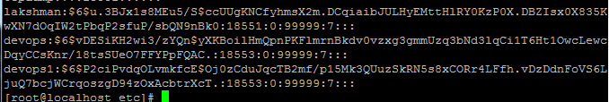
Users and pwds available:-
[root@localhost etc]# cat /etc/shadow
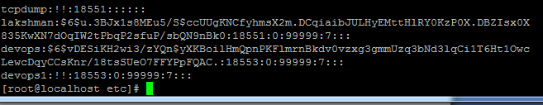

List of logged users :-who
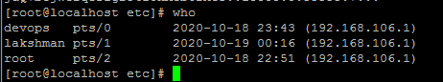 3 users are logged in.

Switch from root to other user:- su -> switch to user (here pwd will not ask root to user)
[root@localhost etc]# su – lakshman
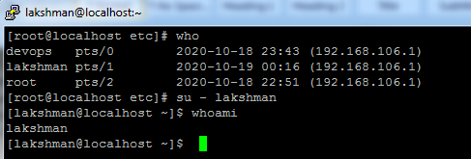
Exit -> exit the user
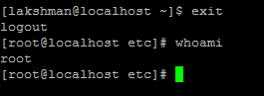
Switch from one user to other user:- su -> switch to other user (here pwd will ask for user to user)
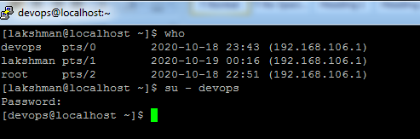
Pwd -> devops1
Switch to root(it will ask pwd):- su – (not given any user by default will take root) – root pwd : devops@123
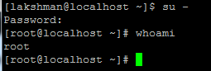
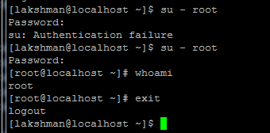
[root@localhost etc]# head /etc/passwd -> head will show first 10 lines
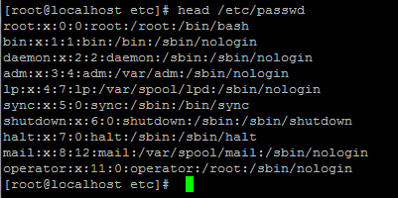
[root@localhost etc]# head -5 /etc/passwd -> head n – specify how many lines
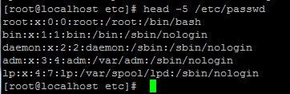

[root@localhost etc]# tail /etc/passwd -> tail will display last 10 lines
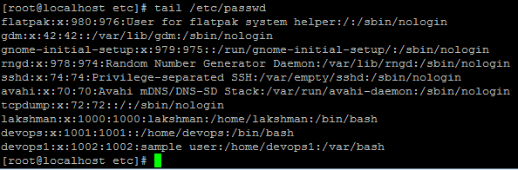
[root@localhost etc]# tail -3 /etc/passwd -> tail n – specify how many lines
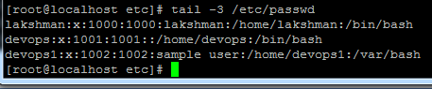

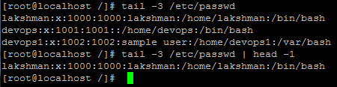

Display Running process:-
[root@localhost etc]# ps –ef (ex: in windows task manager)
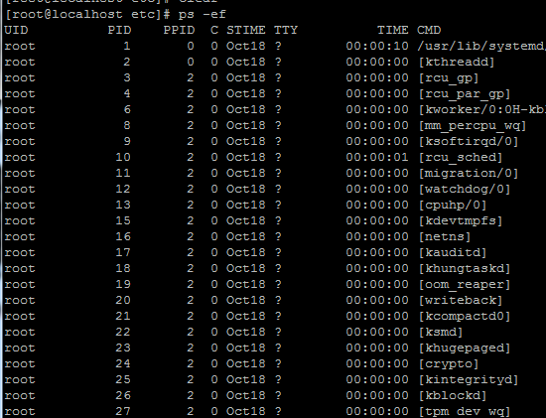
grep -> global regular expression (grep means searching)
[root@localhost etc]# ps -ef | grep tomcat -> only display tomcat service process details.
[root@localhost etc]# kill -9 5564 -> kill any process with pid
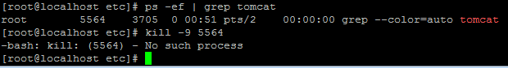
But here tomcat is not processing just we used tomcat to search it will show. After running any process services we will kill it.

How to search specific content in file:-
[root@localhost /]# grep -i "user" sample -> sample is file
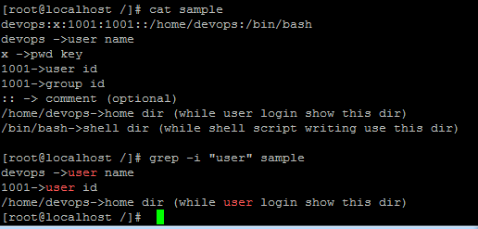
[root@localhost /]# grep -i "user" sample | wc –l -> search will get word count will get it
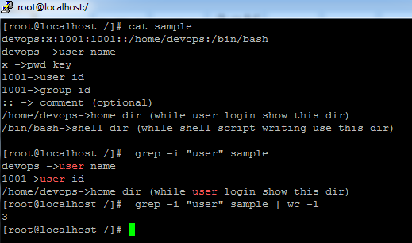

top -> display running tasks related running,sleeping,memory...etc .
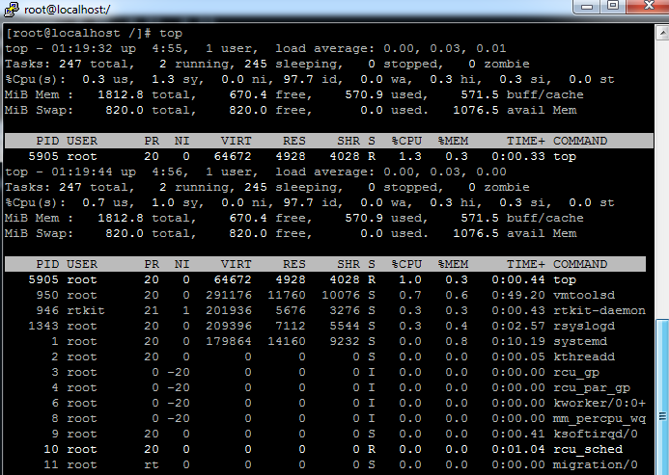
Ctrl+z -> come out
[root@localhost /]# df -> memory will display in kb
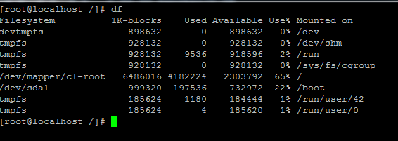

[root@localhost /]# df –h -> memory will display in mb
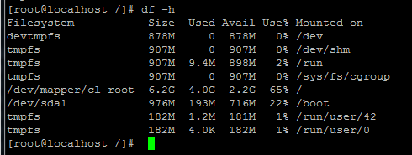
[root@localhost /]# du lib -> disk usage of each file size of dir
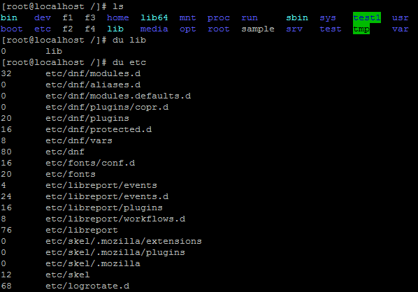
[root@localhost /]# du -sh etc -> all files size
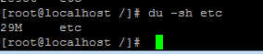
[root@localhost /]# whereis bin -> get predefined softs path of file or dir
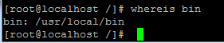

[root@localhost /]# which bin -> get the user definied softs path of file or dir
[root@localhost /]# hostname ->display hostname
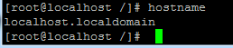

[root@localhost /]# cd /etc/sysconfig/ -> change hostname permanently , provide ur hostname into blow network file ,once restarted server it will pick that host.
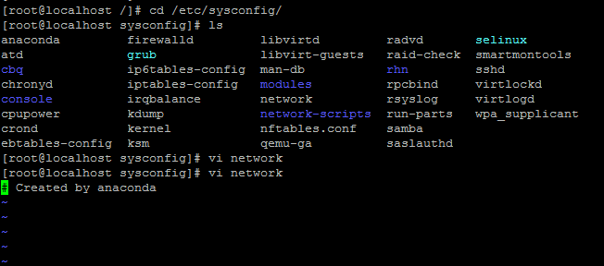
Esc :q! -> quite file without save
[root@localhost sysconfig]# hostname server-1 -> temporarily change hostname .
[root@localhost sysconfig]# sudo –i
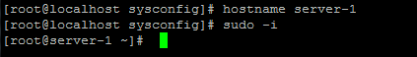

[root@server-1 ~]# yum install wget -> install wget package
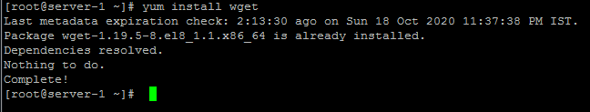
exit
http://maven.apache.org/download.cgi
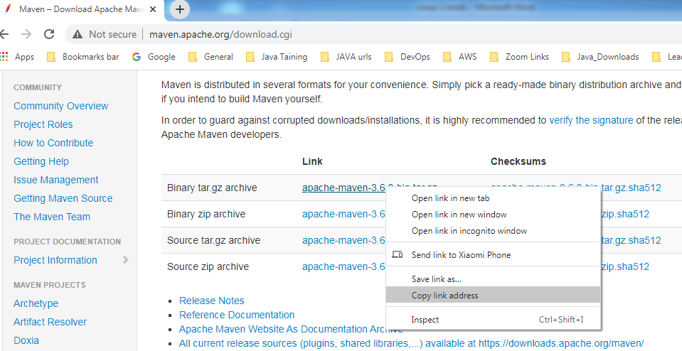

 -> tar is zip format of linux.
[root@server-1 opt]# wget https://mirrors.estointernet.in/apache/maven/maven-3/3.6.3/binaries/apache-maven-3.6.3-bin.tar.gz -> downloaded maven soft

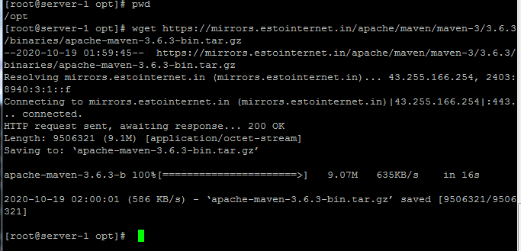

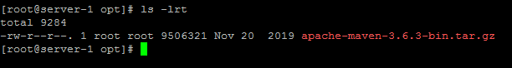
[root@server-1 opt]# tar -xvf apache-maven-3.6.3-bin.tar.gz -> extract the tar zip file
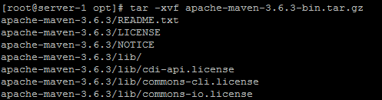
Tar file is extracted
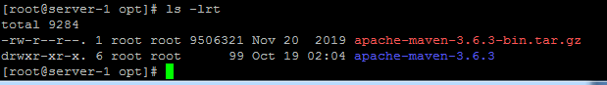

[root@server-1 opt]# tar -tvf apache-maven-3.6.3-bin.tar.gz -> verify inside content without extract the zip file.
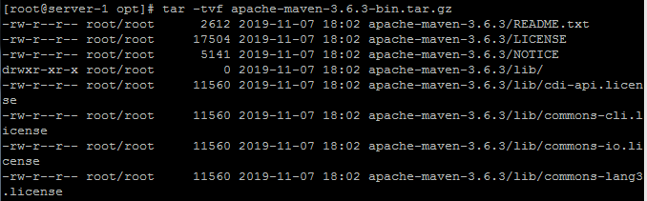
[root@server-1 opt]# rm -rf apache-maven-3.6.3-bin.tar.gz -> removed tar file.
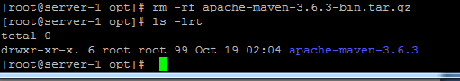

[root@server-1 opt]# tar -cvf maven_new.tar apache-maven-3.6.3 -> tar file created
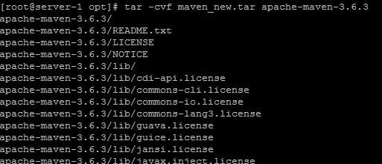
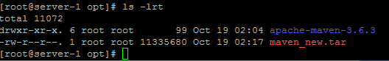

[root@server-1 opt]# netstat -> displays connected http port details
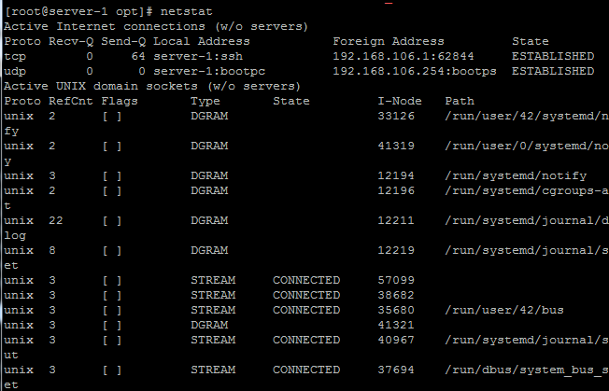
[root@server-1 opt]# netstat -u -> displays connected udp port details
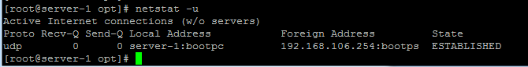
[root@server-1 opt]# netstat -t -> displays connected tcp port details
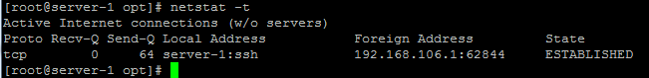
[root@server-1 d1]# ls -> it will show only list of file or dir’s
Note : here i have created 3 files inside d dir.
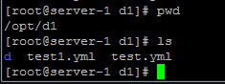

[root@server-1 d1]# ls –R -> it will shows all list of files and inside files of d dir’s
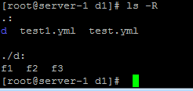
[root@server-1 k]# touch file{1..10} -> to create more files continues files.
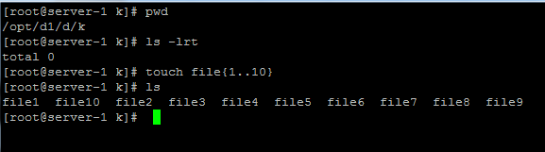
[root@server-1 k]# touch file{11..30..2} -> 11 –initial , 30-max ,2 –increment ex: 11,13,15,17....etc
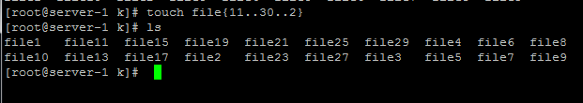

[root@server-1 k]# find / -name "sample" -> find the sample based on name. / - under any dir.
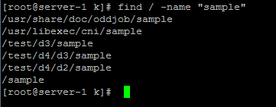
[root@server-1 k]# find / -name "sample" -type d -> -type d - only search dir’s with sample name.
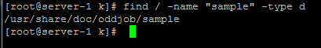
[root@server-1 k]# find / -name "sample" -type f -> -type f - only search file’s with sample name
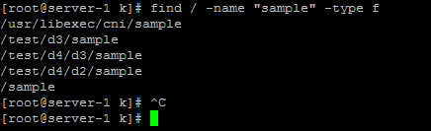
[root@server-1 k]# find / -perm 777 -type f -> search only full permission (-perm) files
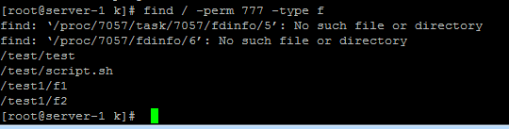
[root@server-1 k]# grep -n "devops" /etc/passwd -> search word in file , -n means line number in the file.
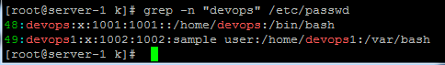

[root@server-1 k]# grep -B2 "devops" /etc/passwd ->search and display before 2 lines (-B2) of devops word .
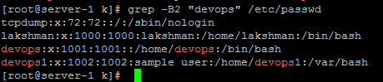
[root@server-1 k]# grep -A2 "lakshman" /etc/passwd ->search and display after 2 lines (-B2) of lakshman.
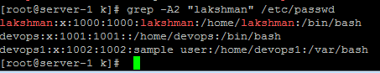
======================================END===================================

